Create Demo Project-React-Webapp Using Docker

🧩 Step 1: Install Prerequisites
Make sure you have these installed:
- Node.js (v16 or higher) → https://nodejs.org
- npm (comes with Node) or yarn (optional)
- Code Editor → VS Code recommended
Check versions:

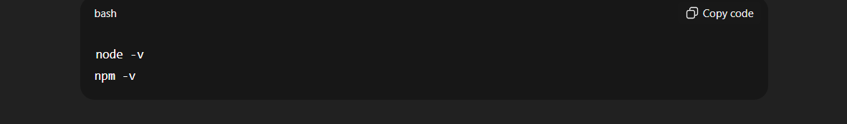

⚙️ Step 2: Create a New React App
Using npx: -

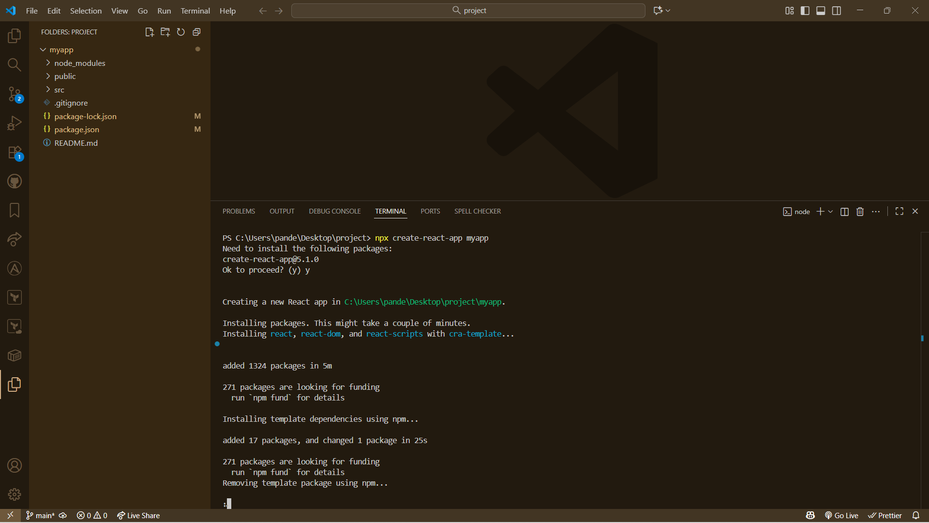
Then:
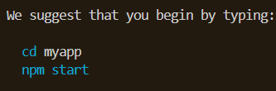

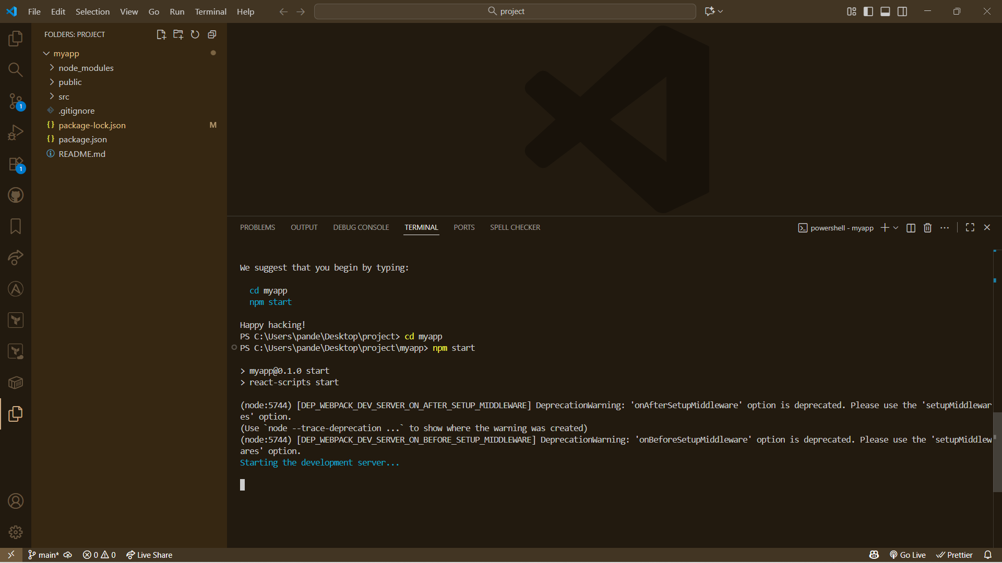

React Webpage: -

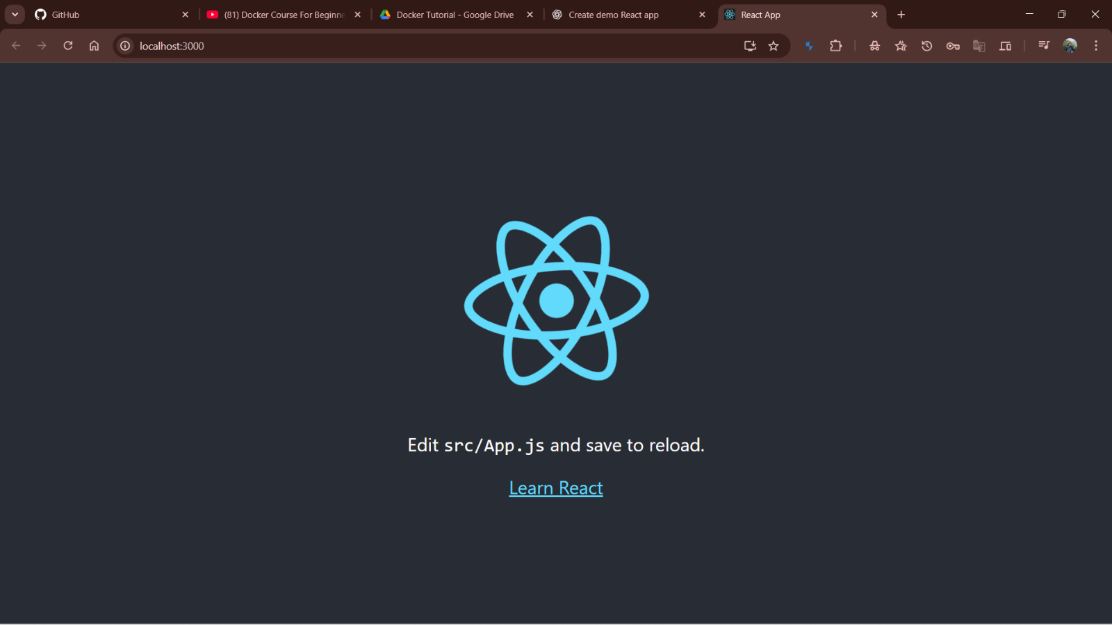

How to create Docker file?
🧩 1️⃣ What is a Dockerfile?
A Dockerfile is a script with instructions to build a Docker image — like a recipe for packaging your app (code + dependencies + runtime) into a container.

⚙️ 2️⃣ Basic Dockerfile for a React App
Create a file named Dockerfile in your project’s root (same folder as package.json):

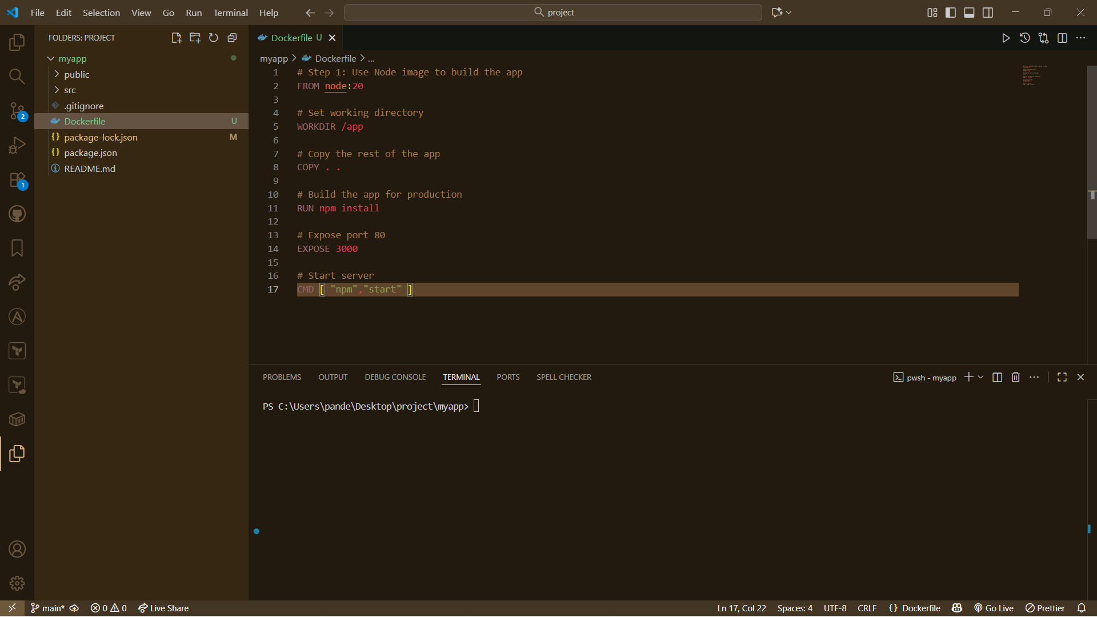

How to Build Docker Image: -
Use Command: -
Docker Build .
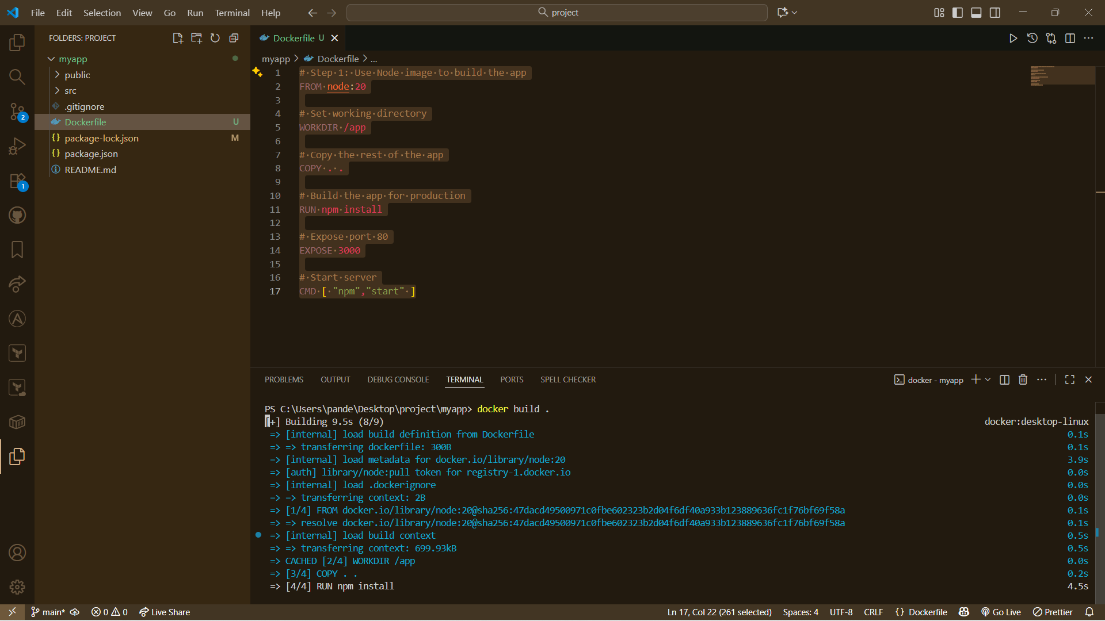

✅ Summary:

Step | Command | Description
1 | docker build -t my-react-app . | Build image
2 | docker images | List images
3 | docker run -d -p 8080:80 my-react-app | Run container
4 | docker ps | See running containers

Docker images: -
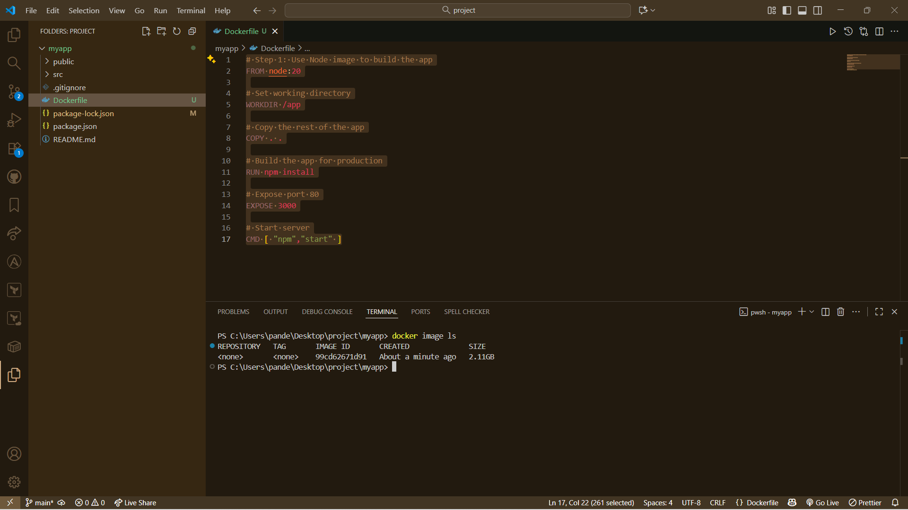

Manage And Running Container: -
Use Command: -
Docker run -image id
Comm.:- docker run -p 3000:3000 99cd62671d91

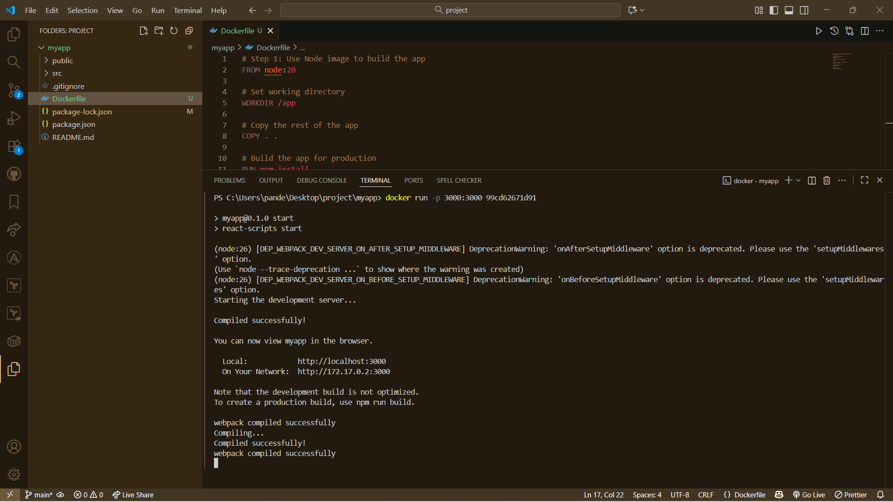

Now See Webpage Is Running on the Docker Container

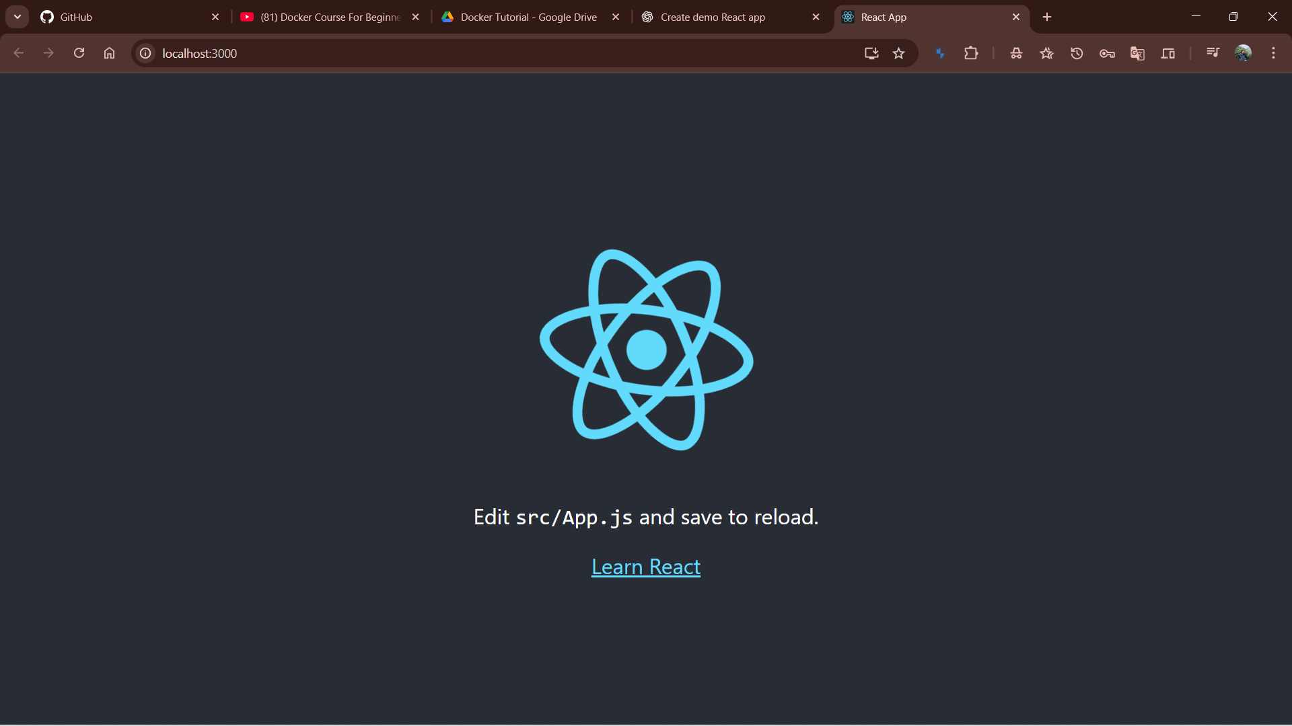

View Of Docker Desktop:

Running Container: -

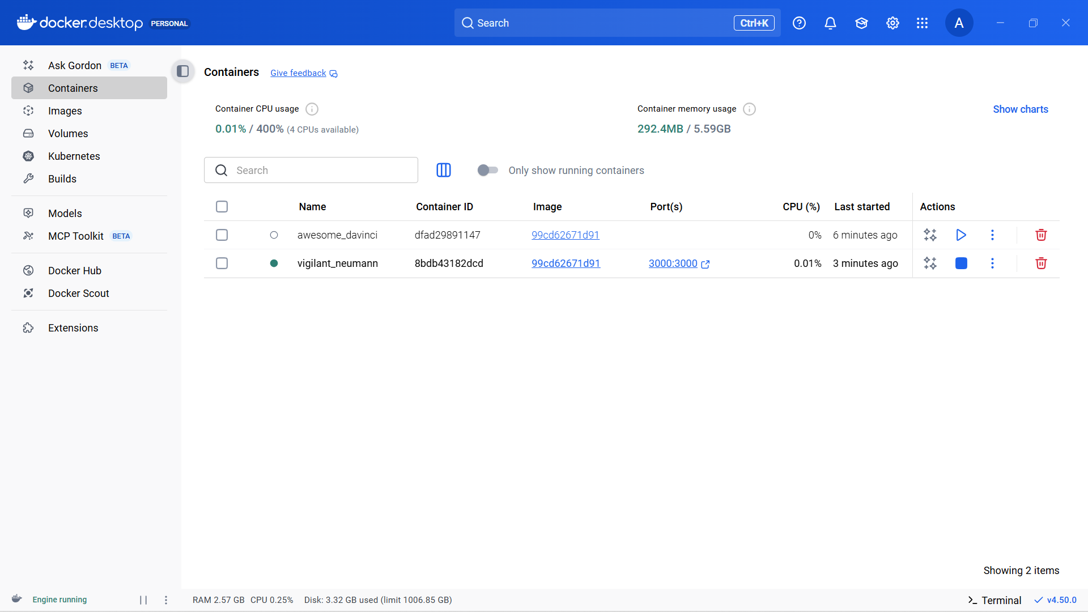

Image: -

